**Internship Report**

**Web Development**

**(MERN Stack)**

## **Submitted to**

**SAVITRIBAI PHULE PUNE UNIVERSITY**

**Submitted By**

**Mr.Saurabh Sanjay Karande**

**UNDER THE GUIDANCE OF**

**Prof. Laxmikant Malphedwar**

**DEPARTMENT OF INFORMATION TECHNOLOGY**

## NUTAN MAHARASHTRA INSTITUTE OF ENGINEERING AND TECHNOLOGY

**Samarth Vidya Sankul Talegaon Dabhade, PUNE-410507 2022-2023**

## AFFILIATED TO



**SAVITRIBAI PHULE PUNE UNIVERSITY**

**PCET’s NUTAN MAHARASHTRA INSTITUTE OF ENGINEERING AND TECHNOLOGY**

Talegoan Dabhade, Pune - 410 507



**DEPARTMENT OF INFORMATION TECHNOLOGY**

**C E R T I F I C A T E**

This is to certify that the Internship report entitled

**Web Development**

**(MERN Stack)**

Submitted by

This is to certify that the “Internship report” submitted by **Saurabh Sanjay Karande & Exam seat no.T190558532** is work done by her and submitted during 2022-23 academic year, in partial fulfillment of the requirements for the award of the degree of BACHELOR OF ENGINEERING in INFORMATION TECHNOLOGY, at Nutan Maharashtra Institute of Engineering & Technology

**DATE-**

# 

**Prof. Laxmikant Malphedwar Prof. Dheeraj Patil (Internship Guide) (Internship Coordinator)**

**Prof.Ashish Manwatkar Dr. Vilas Deotare**

**(Head of Department) (Principal)**

**Acknowledgement**

First I would like to thank **Mr.Swapneel Petkar**, HR, Head, of **Wisdom Sprout.in** for giving me the opportunity to do an internship within the organization.

I also would like all the people that worked along with me **Wisdom Sprout.in** with their patience and openness they created an enjoyable working environment.

It is indeed with a great sense of pleasure and immense sense of gratitude that I acknowledge the help of these individuals.

I am highly indebted to Principal **Dr. Vilas Deotare**, for the facilities provided to accomplish this internship.

I would like to thank my Head of the Department **Prof.Ashish Manwatkar** for his constructive criticism throughout my internship.

I would like to thank **Prof. Dheeraj Patil** & **Prof.Laxmikant Malphedwar**, internship coordinator Department & internship Guide of IT for their support and advices to get and complete internship in above said organization.

I am extremely great full to my department staff members and friends who helped me in successful completion of this internship.

**Mr. Saurabh Sanjay Karande**

**Table of Contents**

|  |  |  |
| --- | --- | --- |
| **Sr. No.** | **Particulars** | **Page No.** |
| **1** | **Offer Letter** | **5** |
| **2** | **Internship completion certificate** | **6** |
| **3** | **Internship Place Details** | **7** |
| **4** | **Acknowledgement** | **3** |
| **5** | **Executive Summary** | **8** |
| **6** | **About the Organization** | **9** |
| **7** | **About the Projects** | **10** |
| **8** | **Weekly Overview of internship activities** | **11** |
| **7** | **Opportunities** | **15** |
| **8** | **Learning** | **16** |
| **9** | **Challenges Faced** | **17** |
| **10** | **Project Results** | **18** |
| **11** | **Conclusion** | **21** |
| **12** | **References** | **22** |

**Offer Letter**

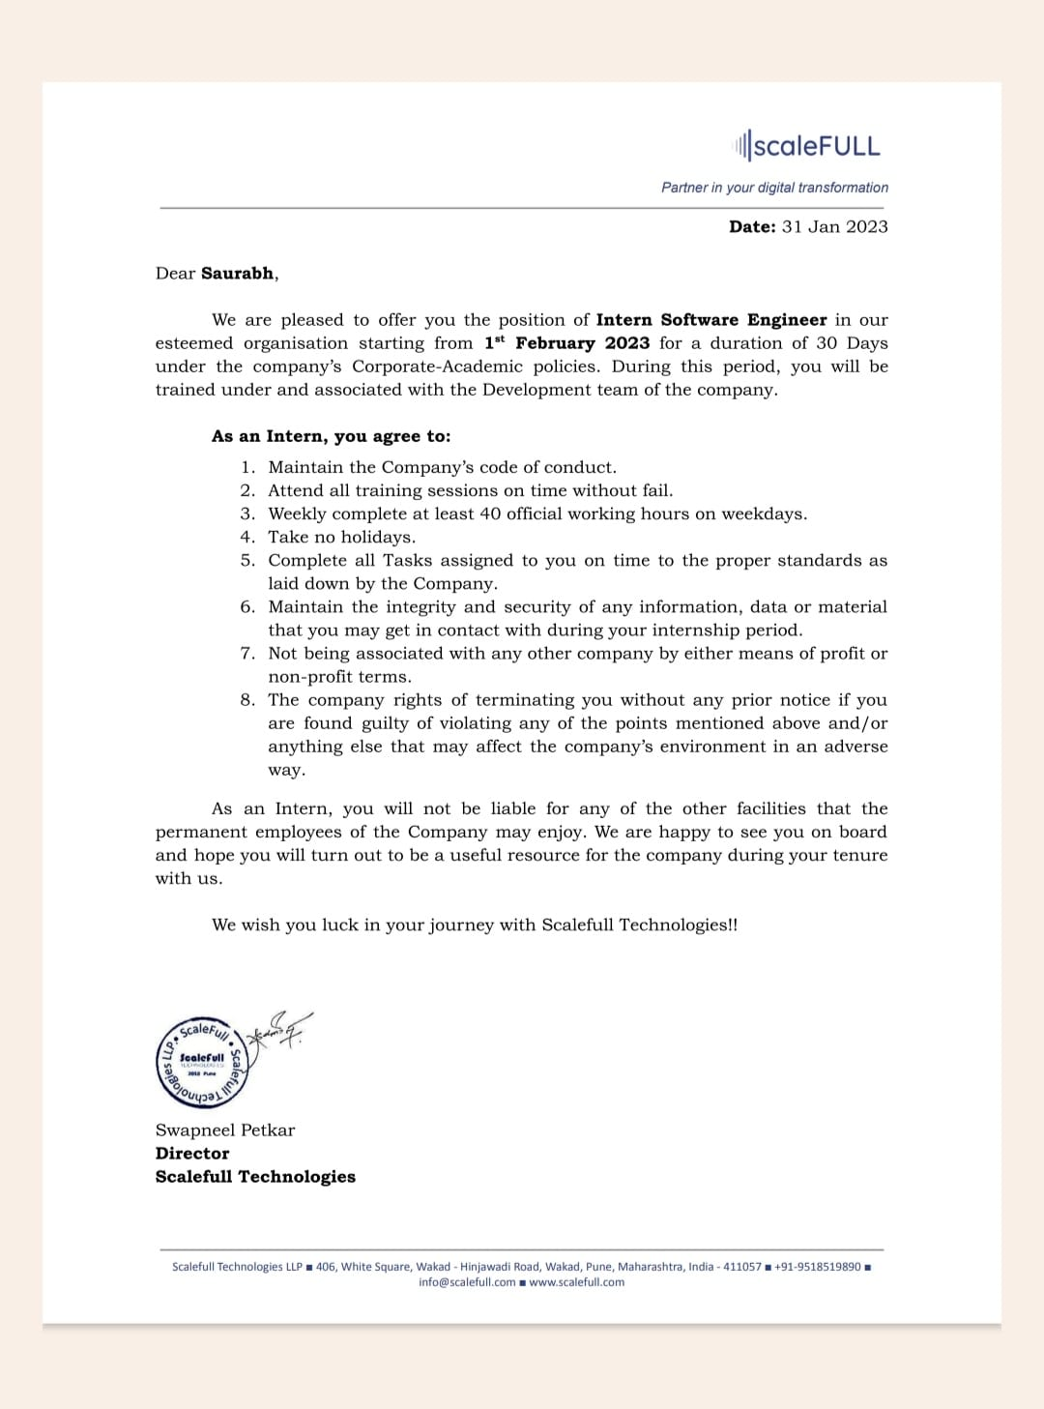

**INTERNSHIP COMPLETION CERTIFICATE**

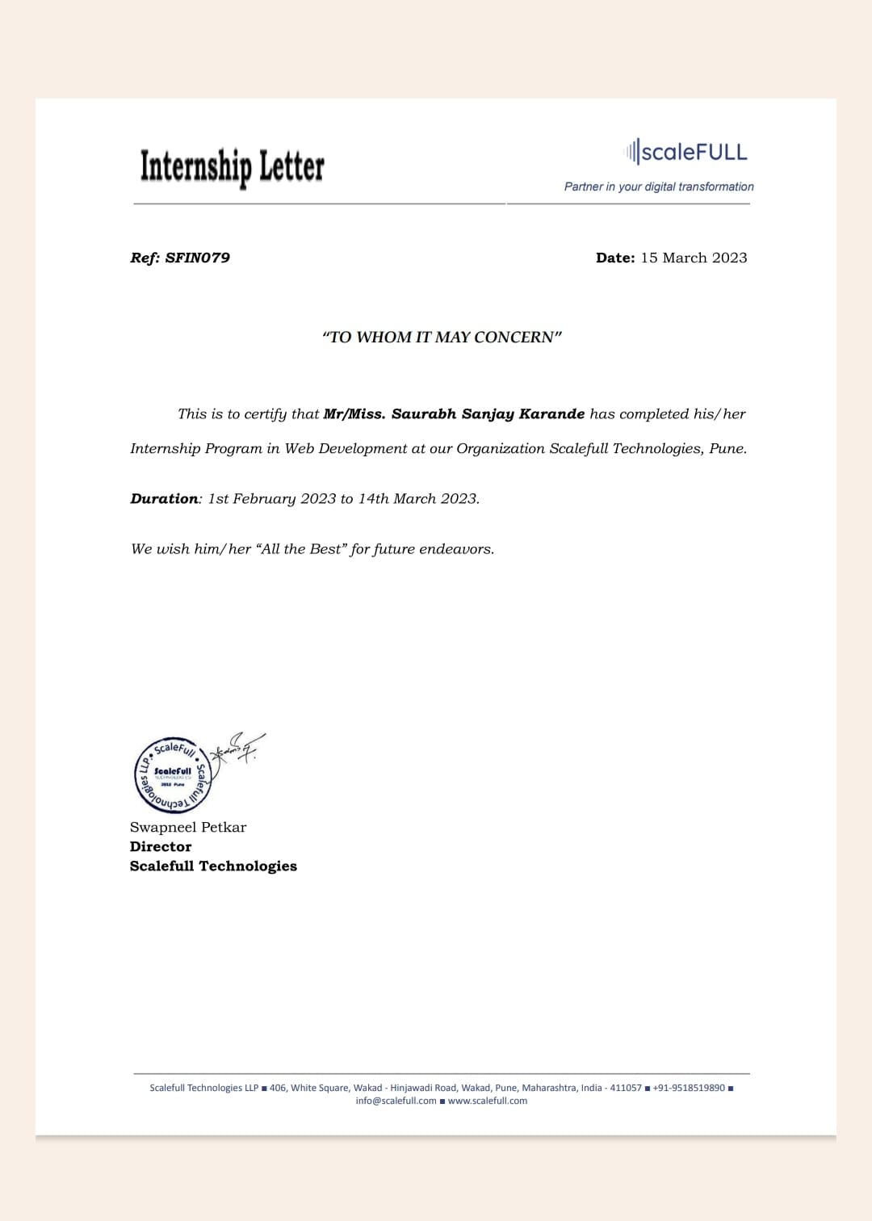

**INTERNSHIP PLACE DETAILS**

* **Company Name :- Wisdomsprout.in**
* **Company Address:- 406'White Square Building, Wakad-Hinjewadi Road, Hinjewadi, Pune**
* **Contact Details:- +91 8390380888 | +91 7770043825**
* **Company Domain:- Web Development**
* **Internship start date:- 1 feb 2023**
* **Internship end date:- 15 mar 2023**
* **Technology Learn:- HTML,CSS,JAVASCRIPT,BOOTSTRAP.**

**Executive Summary**

During my internship in web application development, I had the opportunity to work on several projects that helped me to develop my skills and knowledge in the field. These projects included the development of web applications, mobile applications, and websites, using a variety of programming languages and frameworks.

Through these projects, I gained valuable experience in web development, including front-end development, back-end development, database management, and quality assurance testing. Additionally, I had the opportunity to work with a diverse team of developers and gain exposure to various web development methodologies and project management practices.

Overall, my internship provided me with an excellent opportunity to gain practical experience in web application development and enhance my skills and knowledge in the field. Through the projects I worked on, I was able to apply my academic knowledge to real-world situations and learn from experienced developers in the industry. I also gained valuable insights into the challenges and opportunities in the field of web development, which will be invaluable as I pursue a career in this exciting and rapidly evolving field

**About the Organization**

Wisdom Sprouts which stands today as one of the fastest growing Training and Career Development Platforms based in Pune, having its presence over other parts of India.

Wisdom Sprouts Training and Career Development is a joint venture of Voracii Wisdom Solutions Pvt Ltd and ScaleFull Technologies LLP. We are the technology partners of MongoDB and IBM. Nominated as “Top 5 Big Data Training Institutes to look out for in 2017” by Silicon India, and “10 Best Big Data Training Institute in India -2017” by Higher Education Review, We stand out to be one of fastest growing Training and Career Development Center with a client base of more than 35 Colleges, 15 Companies, and 3 branches.

We proudly call us a first choice of many students when it comes to training. Our faculties, who have multiple years of industry experience make sure that students don’t miss on any part when it comes to their training. We even believe in giving extra to the students than what is promised.

We have a history of delivering what is promised. Around 70% of the students who are trained at Wisdom Sprouts make it to their desired Job. Our specialty is training students who are low in their technical skills, confidence and soft skills. We have seen several examples from our students who have excelled to greater heights after getting trained at our facilities.

Given us a chance, we delivered quality training and workshops during our initial days. Which resulted in partnership / MOUs with more than 21 colleges in and around Pune. Some of our esteemed academic partners are Sinhagad Group Of Institutes, D.Y. Patil group of colleges, Indira College, AISSMS,JSPM to name a few.

In the year 2019, we started our new Branch at Hinjawadi, which is called as biggest IT Hub in Pune. And just within 9 months of operation, we inaugurated new Branch at Akurdi. Hinjawadi branch targets working professionals from IT hub, whereas Akurdi branch attracts college students from Pimpri-Chinchwad area.

We have promised ourselves to stay extremely dedicated towards our goal and keep serving our students, partner colleges and corporate partners.

**About the Projects**

**Doctor Appointment System**

**\*Problem Definition:**

A doctor appointment system is an online tool that allows patients to schedule appointments with their doctors in a more efficient manner. It is a computerized system that automates the process of appointment booking and scheduling, and it helps to reduce waiting times and improve the quality of care.

**\*Features:**

* Appointment scheduling: Patients can schedule appointments with their doctors at any time of the day or night.

**\*Benefits:**

* Improved efficiency: The system automates the process of appointment booking and scheduling, which reduces waiting times and improves the efficiency of the clinic.
* Better patient experience: Patients can schedule appointments at their convenience and receive reminders, which improves the overall patient experience.
* Improved communication: The system facilitates communication between doctors and patients, which improves the quality of care.
* Increased revenue: The system can increase revenue for the clinic by reducing no-shows and allowing patients to pay for their appointments online.

**Weekly overview of internship activities**

* **Week One :** During week One of the training, I was introduced to the basic concepts of Website development. The concepts covered in week One are -

1. What is Website Development ?

Website development refers to the process of creating and building websites. It involves a combination of various tasks such as web design, coding, programming, and content creation to develop functional and visually appealing websites. Website development encompasses both the front-end (client-side) and back-end (server-side) aspects of a website, including user interface design, interactive features, database integration, and server configuration. The goal of website development is to create a website that effectively communicates information, engages users, and achieves specific objectives, such as promoting a business, providing information, or facilitating online transactions.

1. Why Website Development?

Website development is important for several reasons:

Online presence: In today's digital age, having a website is essential for businesses and individuals to establish an online presence. A website serves as a virtual storefront or a platform to showcase products, services, or personal portfolios.

Accessibility and convenience: A well-developed website allows people to access information, products, or services at any time and from anywhere with an internet connection. It provides convenience to users and expands the reach of businesses beyond physical limitations.

Branding and credibility: A professionally designed and developed website helps establish a strong brand identity and enhances the credibility of a business or individual. It allows for consistent branding elements, such as logos, color schemes, and messaging, to be presented across the website, building trust with visitors.

1. What is Front End and Back End ?

Front-end and back-end are two distinct components of a website or web application:

Front-end: The front-end, also known as the client-side, refers to the part of a website or application that users interact with directly. It encompasses the visual and interactive elements that users see and interact with in their web browsers. Front-end development involves creating the user interface (UI), designing the layout, and implementing the functionality that allows users to navigate, interact, and consume content on a website.

Back-end: The back-end, also known as the server-side, is the part of a website or application that operates behind the scenes and supports the front-end. It involves the server, database, and application logic that work together to process requests, handle data storage and retrieval, and perform complex operations. Back-end development includes tasks such as server configuration, database management, writing APIs (Application Programming Interfaces), and implementing business logic.

1. Structure of a HTML program.

The structure of an HTML (Hypertext Markup Language) program typically follows the following format:

<!DOCTYPE html>

<html>

<head>

<title>Page Title</title>

</head> <body>

<!-- Content of the webpage goes here -->

</body>

</html>

1. Creating a simple webpage using Html .

<!DOCTYPE html>

<html>

<head>

<title>My Simple Webpage</title>

</head>

<body>

<h1>Welcome to My Simple Webpage</h1>

<p>This is a paragraph of text on my webpage.</p>

<h2>About Me</h2>

<p>I am a web developer interested in HTML and CSS.</p>

<h3>My Hobbies</h3>

<ul>

<li>Reading</li>

<li>Playing guitar</li>

<li>Hiking</li>

</ul>

<h3>Contact Me</h3>

<p>You can reach me at email@example.com</p>

</body>

</html>

Takeaways from week one are the basics of Web development ,and the tools for developing a webpage using Notepad and Vs code, and the benefits offered by website Development.

* **Week Two :** In week Two of the internship program, we were introduced to the following concepts -

1. Creating a website using different HTML tags.
2. Inserting images, videos, and text in the website.

Takeaways from week 2 learned about inserting images ,videos ,audios in the webpage by using special tags and used radio buttons , inserting tables, and many more in the web page.

* **Week Three :** In Week three of the internship, we had a final project for the certification We were given to problem statement and we were expected to produce to required output for the problem statement

**Opportunities**

My internship in web application development provided me with several opportunities to develop my skills and gain practical experience in the field. Some of the key opportunities that I encountered during my internship include:

Working on real-world projects: One of the most significant opportunities that I had during my internship was the chance to work on real-world projects. This gave me the opportunity to apply my academic knowledge to practical situations and gain experience in various aspects of web development, including front-end development, back-end development, and quality assurance testing.

Learning new technologies: Another significant opportunity that I had during my internship was the chance to learn new technologies and programming languages. Through working on different projects, I was exposed to new frameworks, libraries, and technologies, which helped me to expand my knowledge and skills in web development.

Collaborating with experienced developers: As part of a team of experienced developers, I had the opportunity to collaborate with them on various projects. This gave me valuable insights into their development methodologies, project management practices, and technical expertise.

Gaining exposure to different industries: During my internship, I had the opportunity to work on projects for different industries, including e-commerce, healthcare, and education. This gave me valuable insights into the specific challenges and opportunities in each industry and helped me to develop a broad perspective on web development.

Enhancing communication skills: Working with a diverse team of developers required effective communication skills. This opportunity helped me to enhance my communication skills and collaborate effectively with team members from different cultural backgrounds and communication styles.

Overall, my internship in web application development provided me with numerous opportunities to learn, grow, and develop my skills and knowledge in the field. These opportunities helped me to become a better developer and prepared me for a successful career in web development.

**Learning**

During my internship in web application development, I had the opportunity to learn and develop my skills in various aspects of web development. Some of the key learnings that I acquired during my internship include:

Front-end development: I learned how to develop the user interface of web applications using HTML, CSS, and JavaScript. I gained practical experience in creating responsive and visually appealing web pages that meet industry standards and user requirements.

Back-end development: I learned how to develop the server-side of web applications using frameworks such as Node.js and Django. I gained practical experience in developing APIs, handling database operations, and managing server-side scripting languages.

Quality assurance testing: I learned how to perform quality assurance testing to ensure that web applications meet industry standards and user requirements. I gained practical experience in creating test cases, testing user interfaces, and debugging and fixing issues in the code.

Project management: I learned how to manage projects effectively, including creating project timelines, tracking project progress, and collaborating with team members. I gained practical experience in using project management tools such as JIRA and Trello.

Collaboration: I learned how to collaborate effectively with team members, including developers, project managers, and clients. I gained practical experience in using tools such as Slack and Zoom to communicate and collaborate with team members remotely.

Continuous learning: I learned the importance of continuous learning in the field of web development. I gained practical experience in learning new technologies and programming languages to stay up-to-date with the latest industry trends and developments.

Overall, my internship in web application development provided me with an excellent opportunity to learn and develop my skills in various aspects of web development. The practical experience that I gained during my internship will be invaluable as I pursue a career in this exciting and rapidly evolving field.

**Challenges Faced**

During my internship, I faced several challenges that helped me to grow as a web developer. One of the significant challenges I faced was working with tight deadlines. In many cases, I had to complete a project within a short timeframe, which required me to work quickly and efficiently. This challenge taught me how to manage my time effectively and prioritize tasks to meet deadlines.

Another significant challenge was dealing with unexpected technical issues. Sometimes, I would encounter bugs or errors in the code that would require significant troubleshooting to fix. This challenge taught me how to debug and test my code effectively and work collaboratively with other developers to solve complex technical issues.

Working with a diverse team of developers was also a challenge, as communication and collaboration were sometimes difficult due to different communication styles and cultural backgrounds. This challenge taught me the importance of effective communication and collaboration in a team environment and helped me to develop my interpersonal skills.

Lastly, learning new technologies and programming languages was also a challenge. As a beginner in web development, it was sometimes difficult to learn and adapt to new technologies quickly. However, this challenge taught me the importance of continuous learning and staying up-to-date with the latest web development trends and technologies.

Overall, my internship in web application development provided me with numerous challenges that helped me to grow and develop as a web developer. These challenges taught me valuable skills and helped me to become more confident in my abilities as a web developer.

**RESULT**



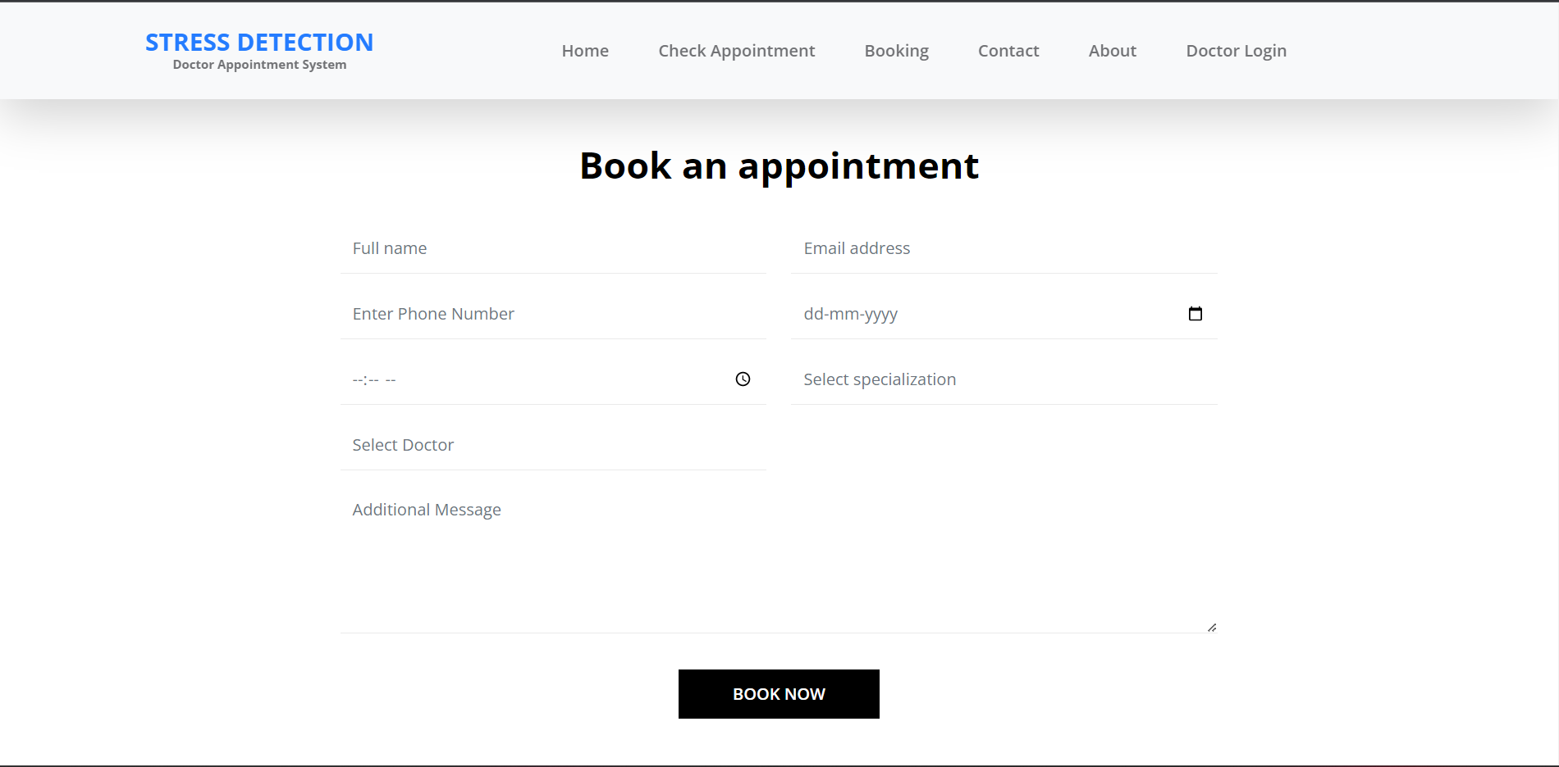

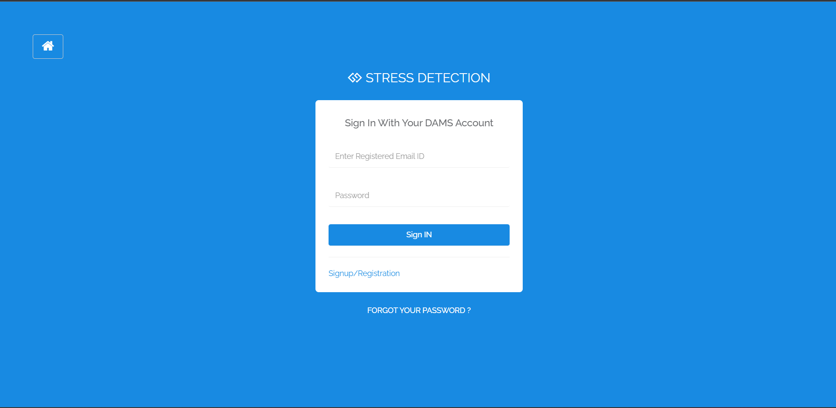

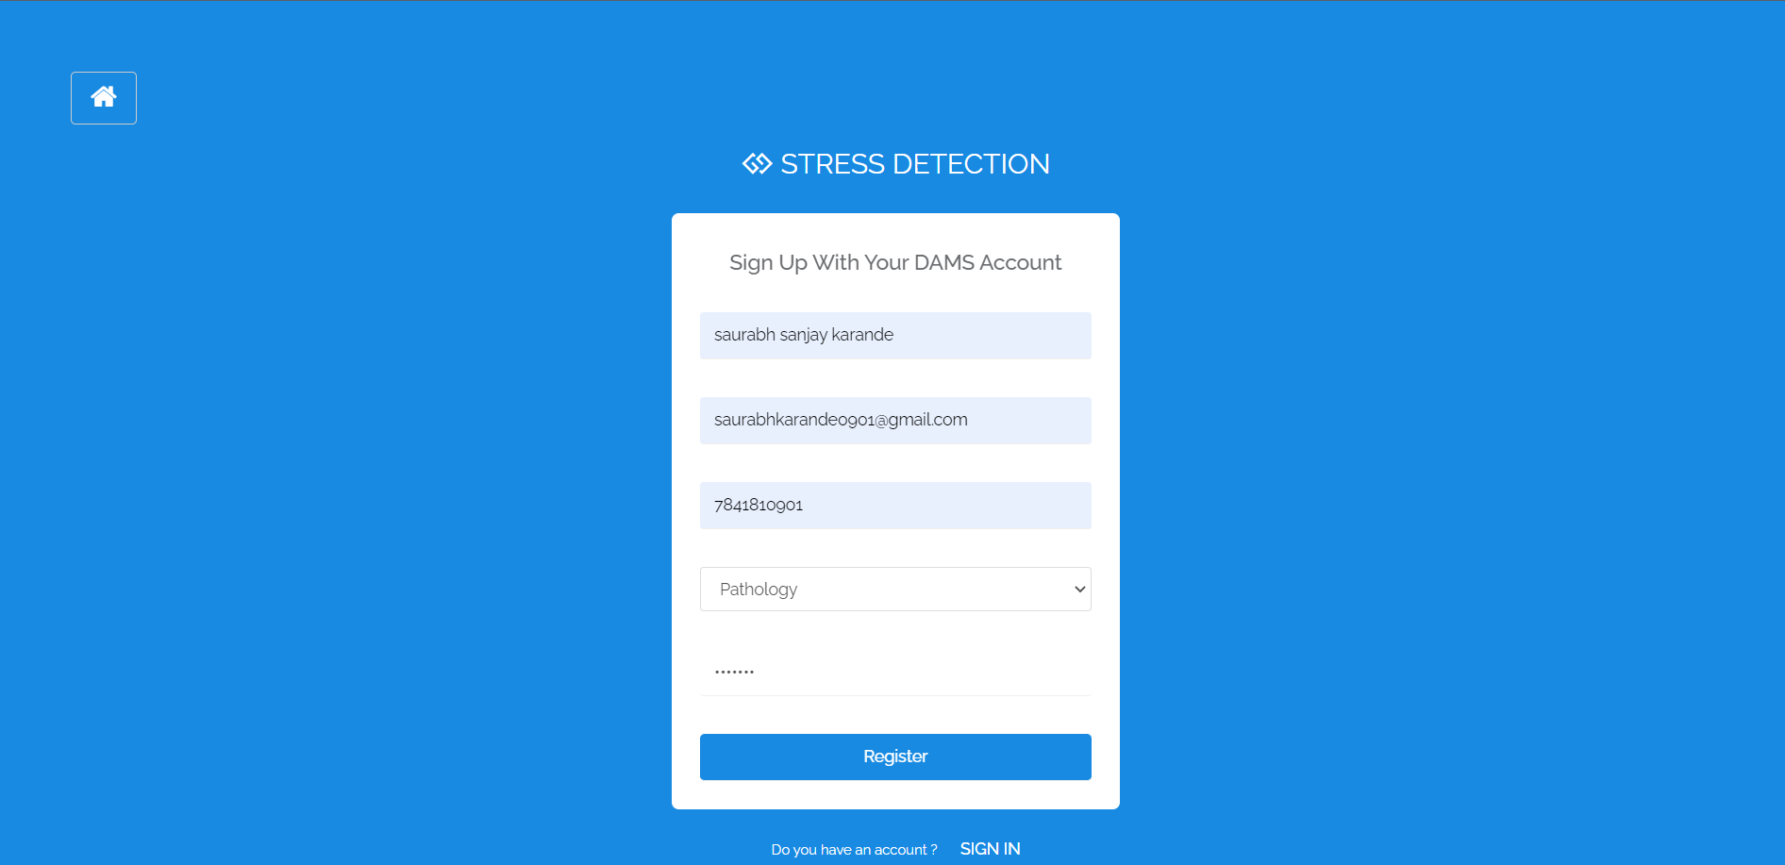

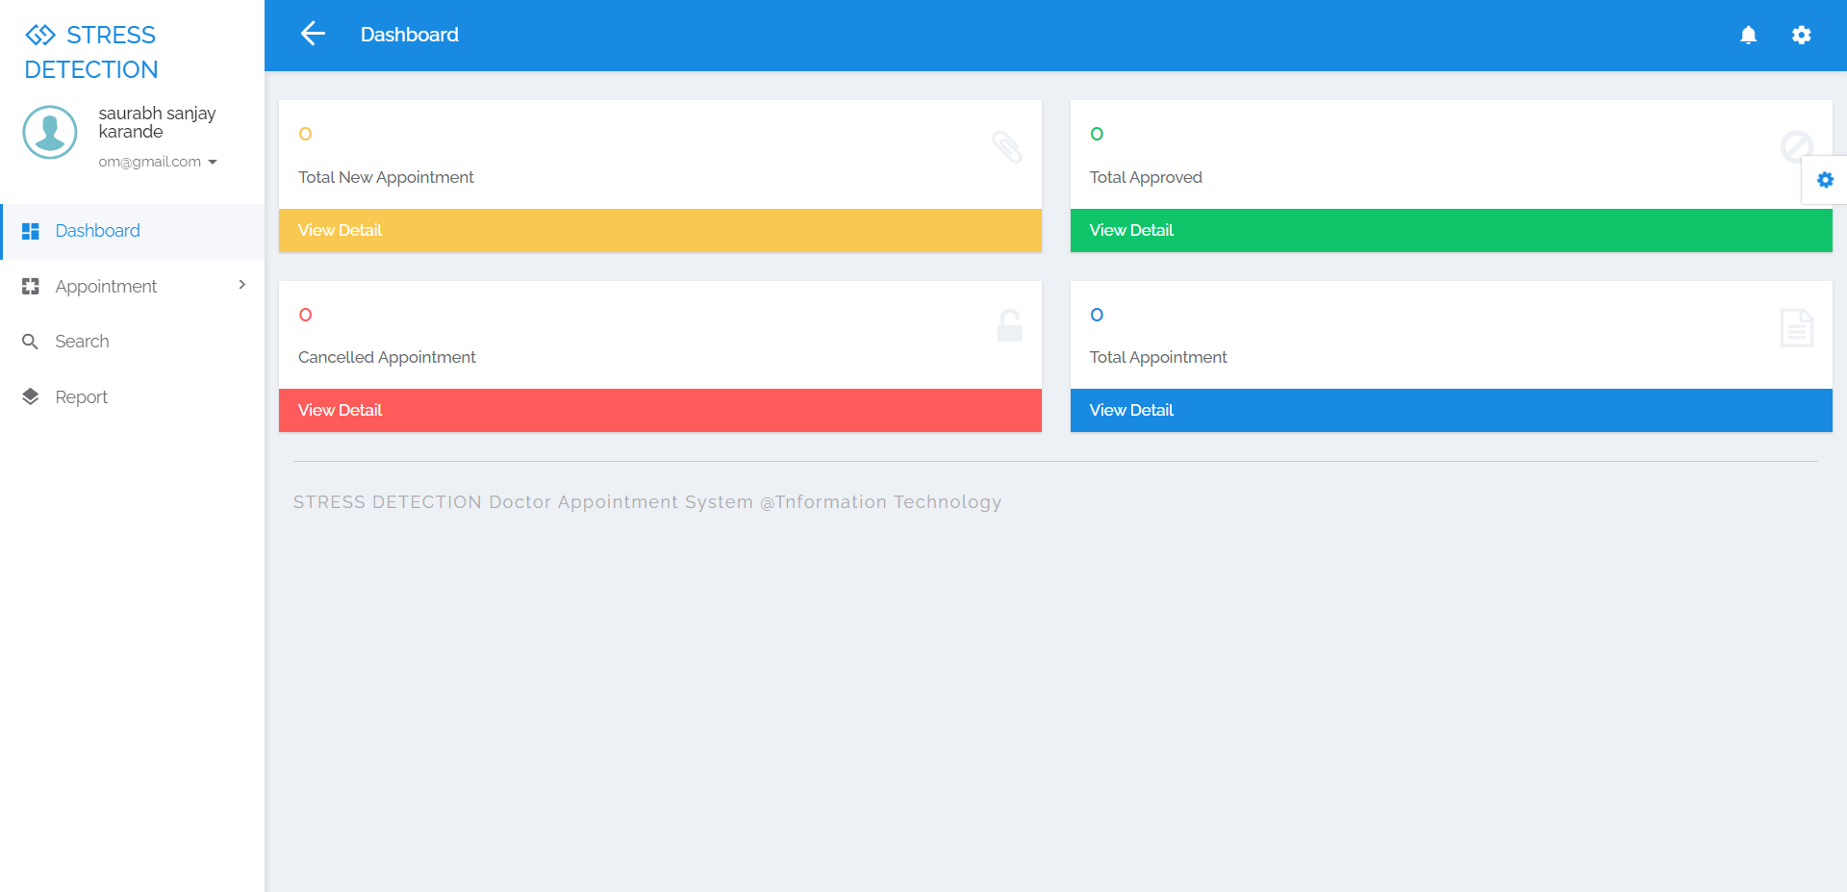

**CONCLUSION**

With the development of web based NHIS medical appointment booking system, patients are able to book and manage their own appointment with ease. They will be reminded of their appointments via SMS/email that will be promptly sent to them before their appointment date. The system itself also provides a quick view of their appointment at the Home page. These functions could indirectly help to reduce the number of missed medical appointments and patients no-show up for their appointment.

**References**

1."Building Web Applications with Visual Studio 2017: Using .NET Core and Modern JavaScript Frameworks" by Philip Japikse, Kevin Grossnicklaus, and Ben Dewey - This book includes a chapter on building a weather web application using .NET Core and Angular.

2."JavaScript: The Definitive Guide: Activate Your Web Pages" by David Flanagan - This book includes a section on using JavaScript to access weather data from web services and display it on web pages.

3."HTML5 and CSS3 Responsive Web Design Cookbook" by Benjamin LaGrone - This book includes a chapter on building a responsive weather web application using HTML, CSS, and JavaScript.

4.OpenWeather API - OpenWeather API provides weather data for developers to use in web applications. It offers both free and paid plans, and supports a variety of programming languages including JavaScript, PHP, and Python.